

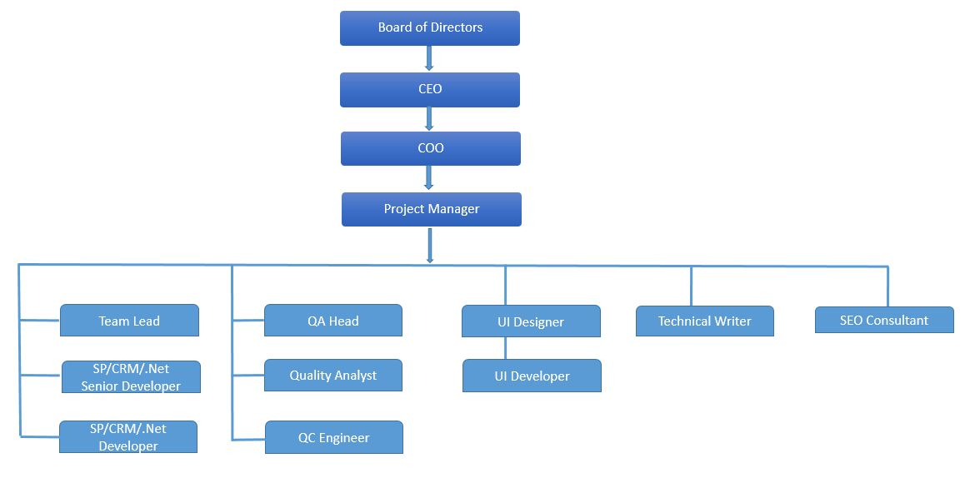
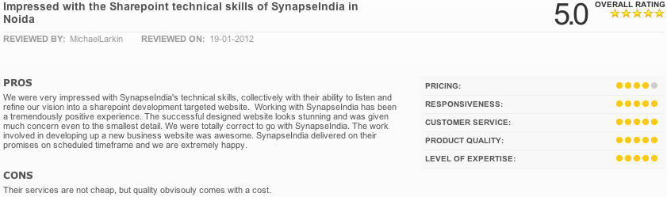
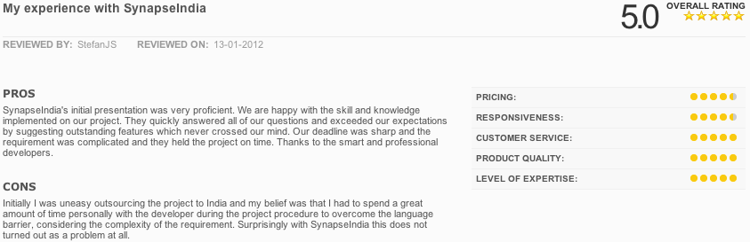
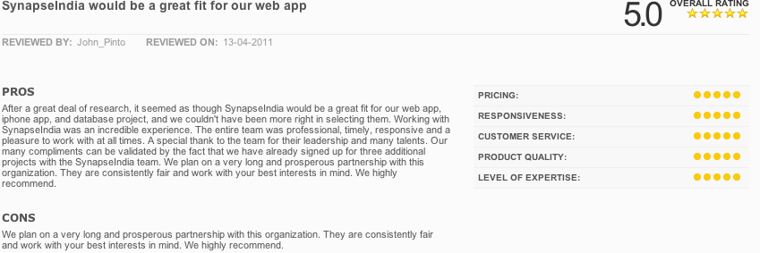
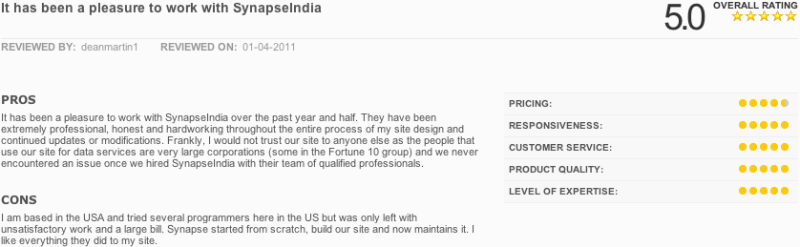
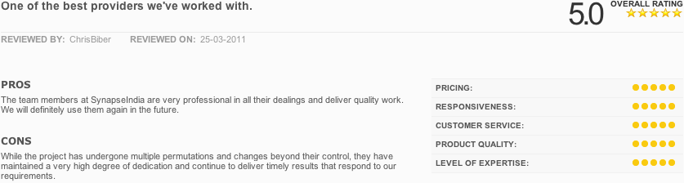
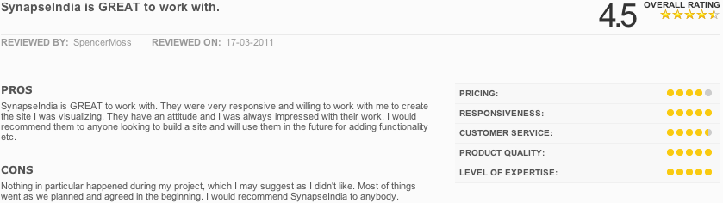

Lawyer Directory Website and Mobile Application Development

Email: solutions@synapseindia.com
Website: www.synapseindia.com

Tel: +91-120-429-0800

Version 1.0- Created July 06th 2018

Client Details:

Richard Dib
Managing Partner
T +961 1 957 586
M +961 3 316 042
W www.dc-ls.com
D&C Legal Services
Deeb & Co Legal Services License 001
Level 2, suite 2019, Louis Vuitton Bldg. allenbly Str. Beirut Souks, Lebanon

INTRODUCTION:

Project scope entails for the creation of Lawyer directory website and mobile application. The solution will allow the users to search for the lawyers and able to communicate with them on email. Also the Lawyers are able to register on the website/application. They are able to choose the scrubscription plans as managed by admin.

Further description of the project has been mentioned under the scope of work.

About SynapseIndia

Listed below are some key highlights about the company:
- Been in the industry for over 18 years
- Successfully delivered over 10,000 solutions to clients worldwide
- Experienced team of over 350 resources
- Four state of the art development centers in National Capital Region India
- Key leadership team in place, in India
    - Senior Management
    - Platform Heads
    - Project Managers
    - Group Heads
    - Team Leads
    - Client Delivery Managers

Microsoft Gold Partner
SynapseIndia was awarded with the Gold status after achieving the rigorous requirements of both advanced infrastructure and information technology programmers across various Microsoft platforms. Microsoft has taken our feedback from a number of our previous client and has independently verified each of them. Being a committed Microsoft Gold Certified Partner, SynapseIndia has in-depth access to a variety of exclusive resources and early product information. We are Microsoft certified Gold partner and have partner competencies in 10 categories

Gold Application Integration
Gold OEM
Gold Communications
Gold Application Development
Silver Midmarket Solution Provider
Silver Data Platform
Silver Hosting
Silver Devices and Deployment
Silver Data Analytics
Silver Collaboration and Content
Silver Intelligent Systems
Silver Datacenter

- One stop provider for all IT needs: design, development, maintenance of web applications, intranet applications, desktop applications, mobile applications, server administration and internet marketing services
- Scheduled data backups at all times on all servers.
- Disaster recovery management system to ensure zero loss of data and minimum downtime.
- Centralized access control system.
- Ensure redundancy of all critical servers.
- Multiple redundant internet connectivity and communication options

SynapseIndia Organization Structure

For the project, we will be assigning a Project Manager, who will be assigned with a team of Programmers and Senior Programmers, with QC resources, UI designer, UI developers. The QC resources will be reporting to the Project Manager.

Company Size

Number of Developers : 250+
Number of Administrators : 18
Number of Analysts : 24
Number of Managers : 40
Number of Support and Misc. Staff : 40

Services Offered
We provide services in various platforms:

Microsoft | Open Source | User Interface
.NET (both C# & VB.NET)  SharePoint 2010 & 2013  MOSS 2007  Dynamics CRM  MSSQL  Silverlight  DNN  AspDotNetStorefront  Orchard CMS | PHP  Shopify  Magento  Zend 1 & 2  CakePHP  Laravel  MySQL  Angular  RoR  Python  Joomla  Drupal  WordPress  Opencart  SocialEngine | Graphic Design  HTML5  Responsive design  Adobe Photoshop  Adobe Dreamweaver  Corel Draw  Ajax  JQuery / JQuery Mobile  Multiple UI frameworks like Twitter BootStrap/ Zurb/ Dojo/ ExtJS/ MooTools
Besides the above, SynapseIndia offers:
- Mobile app development on iOS, Android, Windows Phone, Xamarin platforms
- Internet Marketing: SEO/SEM/PPC

DEVELOPMENT PROCESS

The development process that we follow is in the line of the Waterfall approach. The development process follows six distinct steps. The process of design and solutions development works in tandem with a distinct process of communication with our clients. This helps us to create the best possible solutions in the shortest possible time for our clients.

- System Analysis & Evaluation: This stage essentially deals with understanding the scope of the project to the fullest. There is a detailed interaction with the client at this stage. We prefer that this be through chat - instant messenger - aol/icq/msn/yahoo etc. This usually answers most primary details, required to begin the project.

  - Resource requirements
  - Review business requirements
  - Assign resources, determine start date, duration, and major work components
  - Develop schedule

- Design: Designing the architecture based on the requirements backed by concept inputs. The actual user-interface is developed at this stage. Parallelly the development team prepares the database structure for the project, the solution architecture, object oriented design, modules and interfaces.

  - Develop data architecture (logical and physical data model)
  - Develop application architecture (objects/ modules groupings, internal & external interfaces, user views (screens))
  - Develop technology architecture
  - Define implementation strategy (impacts, risks, hardware/software, acquisition)
  - Define conversion requirements
  - User interface design
  - Database design
  - Base classes definition

- Construct & Implementation: At the implementation stage, we define the organization of the application and how it is to be developed. Subsystems are delineated and organized. Each developed component can then be tested and the results obtained from our different technical teams are then integrated into a final system. Throughout the implementation stage the application will be hosted on our internal servers.

  - Code programs/objects
  - Conduct unit tests
  - Match with specification
  - Integration of various modules and units

- Beta testing: Specially designed quality checks on individual components of the system, as well as on the integrated system ensure a high performance of the product. On-line beta testing completes this process. Test each software unit and database ensuring that it satisfies requirements

- Rectification: This stage involves minor changes and errors arrived at beta testing.

- Delivery: Delivery of the application after receiving client’s approval. The application will be installed on the client server after project completion.

CLIENT REVIEWS – Verified by Microsoft

Some selective client speaks – verified by Microsoft:

PROPOSED PLATFORM

Development of website, administrator and webservcies will be done using Angular JS and Laravel

Development of Mobile application will be done using Swift and Java.

iPhone | iOS 9.0 to 11.2 for phones/iPad
Android | OS 4.4 KitKat to 8.0 Oreo for phones/Tab
User Interface for Website | HTML5 with Angular 2, Bootstrap
Browser | Latest stable version of Safari, Edge, Chrome and Firefox for Desktop Windows.
Back End Programming | Laravel - PHP Framework
Database | MySQL
Sever | Red Hat Linux

SCOPE OF WORK:

Design

- Main Design of the Home page and other main pages will be provided by the client.
- HTML Slicing of the home page and 6 unique inside pages PSD files provided by the client.
- HTML5 with Angular JS, Bootstrap
- Graphic design of application icon and splash screen
- Design of up to 10 screens for iPhone/iPad and Android/Tab
Website Development

- Homepage: Website allow the user to view the homepage of the website there would be a search section where users would be able to search lawyer
  - Header Menu:
    - Site logo/ Site name
    - Menu bar
      - Find Lawyers button
      - Lawyer categories
      - About us
    - Register and Login option
      - Do you Have a case bottom
      - Register you Law firm bottom.
  - Image Slider / Banner
  - Search Panel
    - Search by Location and Category or Both
  - Top lawyers
  - Social Media Icons
  - Static content pages quick links.
  - Short animation video to be posted on the Home Page
    - The video will be provided by the client.
  - Newsletter subscription
  - Main Button that will switch the home page between (Lawyer and User)
  - Bottom to change the Language from (English, French, Spanish)
  - Following links are appear on the bottom of the homepage:
    - About us: Allow the user to view the static information on about us page.
    - Who we are: Allow the user to view the static information on Who we are page.
    - Contact us: Allow the user to view the address details on the contact us page
    - Featured Lawyer: Allow the user to view the features lawyer updated by an admin.
    - Fill out a form and find a law firm: Allow the user to fill some details such as name, email id, phone number and an email will be sent to admin for finding a suitable law firm.
    - Our Philosophy: Allow the user to view the static information on the philosophy page.
    - PDF manuals: Allow the user to view the PDF manuals uploaded by admin
    - Terms of use: Allow the user to view static content on terms of use page.
    - Privacy policy: Allow the user to view the static content on the privacy policy page.
    - Disclaimer: Allow the user to view static content on the disclaimer page.
    - Sitemap: Allow the user to view the sitemap.
- Registration page: Website allows the customers to register on the website to create their profile and send email to a lawyer. Following are the details are required to be entered while the registration process:
  - Name
  - E-mail ID
  - Phone number
  - Address/ Location
  - Password
  - Confirm password
    - Once a user has been registered an automated mail will be sent to their registered E-mail ID with a link. The user can click on the activation link to activate their account and do further processing.
      - Users are able to register through other social media platform
        - Facebook
        - LinkedIn,
        - Twitter
- Login and forgot password Page: Users are able to log in after successful confirming their registration process by using their email address and password. A user can change their password anytime. In case of forgetting the password, a user can recover their password by entering their email address whereby they will get a link in their email inbox to reset their forgotten password.
- Manage User Profile Page: User can log in using their credentials and update their information entered during the registration process.
- Search and filter Page: User can search lawyers by entering a keyword. Users can filter the search by using filters like
  - Location,
  - Popular lawyer
  - Ratings.
  - Expertise
- Search results Page: User can view a list of all the accountants/ advisers and the following information will get displayed on the website page and mobile application:
  - Name
  - Profile picture
  - Location
  - Ratings
  - Year of experience
  - Description about them
    - Allow the user to click on their name or photo they will be directed to the respective lawyer’s profile.
      - Allow users to view lawyers in search results based on lawyer’s subscriptions.
      - The premium lawyer will appear before the basic lawyer
- View Profile Page: User is able to view lawyers profile in detail with the following information available:
  - Full name
  - Profile Photo
  - Location
  - Years of experience
  - About description
  - Specialization category
  - Ratings
    - Users are not required to log in for sending e-mail
    - The users can view the full profile without login. Logged in user are able to rate the lawyer and will have additional matters. A user can select the lawyer after login and they will send lawyer an email so that the lawyer will contact him and admin will be able to send an email to the lawyer as well.
- User/Lawyer (Without Login)
  - User/Lawyer is able to browse the public website.
  - The user is able to find the lawyers by the lawyer name or type of lawyer profile, location.
  - The user is able to view the listing of lawyers and their ratings.
  - The user is able to view the details of the Lawyer
  - Logged in user can do all the above activities plus they can send a question through the platform the certified lawyer and the user can rate the lawyer.
- Send an Email from the website: User can send email to the lawyer by entering the following information:
  - Full name
  - Address/ Location
  - Add attachment
  - Submit
    - Once their inquiry has been submitted, the lawyer will receive an email for the enquiry on their registered email address. The user will also receive an e-mail which will be sent to the customer confirming that the lawyer will get in touch with the user
- Rate Lawyer Page: Website allow the user to rate Lawyer once they log in to the system
- My Dashboard Page: Website allows the user to adjust their account settings and can change their password.
  - The user can edit their profile as well with details such as:
    - Name
    - Email
    - Image
  - The user has the option to log out.
  - The user can rate each lawyer only one and the user is required to log in for completing the rating process.
- CMS Pages: Customers can view all the content pages of the website like:
  - About us
  - Contact us
  - Terms and conditions
  - Privacy policy
- Chat Support: Once a user enters in the website they are able to view a chat support at the bottom of the website and will pop up automatically.

- Lawyer Web Module
- Registration Page: Allow lawyer to register to create their profile. Following are the details entered by the lawyer to complete the registration process:
  - Name
  - E-mail ID
  - Phone number
  - Address/ Location
  - Expertise
  - Number of lawyers
  - Lawyers can register additional office for additional payment
  - Password
  - Confirm password
- Once a lawyer is registered, they will receive an automated mail to their registered E-mail ID with a link. A lawyer can click on the activation link to activate their account.
- Subscription: There will be 4 different type of subscription process available to the lawyer:
  - Basic: A lawyer can list only name address and phone number
  - Premium: A lawyer can upload their own logo, pictures email website expertise summary about the firm, publish an article (Blog))
  - Premium Plus: A lawyer will have all the above plus lawyer will receive contact or email form users directly. A lawyer can be certified by uploading some documents.
  - Gold: A lawyer will have all the above features plus we will be able to send automatic updated on Article, new laws.
    - Gold member lawyer is able to select that he is interested in any potential new law in Lebanon and France.
    - Gold Member lawyer will receive an update for France or Lebanon and automatic e-mail like a newsletter.
- The lawyer is able to view the rating given by the user.
- Login Page: Lawyer is able to log in using their email and password.
- Forget password page: Lawyers can recover their forgotten password by entering their E-mail address whereby they will get a link in their E-mail inbox to reset their forgotten password. Lawyers can change password anytime
- Profile Page: Lawyers are able to upload information required and can upload their profile picture. Lawyers are able to enter the following information:
  - Full name
  - Profile Photo
  - Location
  - Years of experience
  - About description
  - Specialization category
  - Additional information
  - Additional Offices. ( link all the office together )
  - Show all another colleague that are working in the same office
  - Summary about the firm
  - Publishing article
  - A lot of other similar information
  - Ratings (View only)
- Setting Page: Lawyer can manage their password from this section by providing
  - Old password
  - New password
  - Confirm new password
- Membership Subscription Page: Lawyer can subscribe from different types of membership to list their profile. Lawyers can subscribe based on monthly/ yearly based subscription.
  - Stripe Payment Gateway integration for the Membership Subscription. Also, payment should be through Credit card/Debit card, PayPal, Visa, and MasterCard.
- Logout Page: Lawyer can logout from the application and website.

Mobile Application Development (Native iPhone And Android)
- Application icon and Splash screen: Mobile application allows the user to view the application icon and the splash screen will appear for a few seconds.
- Home Screen: Application allows the user to view the home screen and a search section where users would be able to search lawyer. The user will be able to view the following menu section:
  - Site logo/ Site name
  - Menu bar
  - Find Lawyers button
  - Lawyer categories
  - About us
  - Register and Login option
  - Image Slider / Banner
  - Search Panel
  - Top lawyers
- Registration Screen: Mobile application allows the customers to register on the application to create their profile and send email to a lawyer. Following are the details are required to be entered while the registration process:
  - Name
  - E-mail ID
  - Phone number
  - Address/ Location
  - Password
  - Confirm password
    - Once a user has been registered an automated mail will be sent to their registered E-mail ID with a link. The user can click on the activation link to activate their account and do further processing.
      - Users are able to register through other social media platform
        - Facebook
        - LinkedIn,
        - Twitter
- Login and forgot password Screen: Application allows the users/lawyers to log using their username and password. They will view their respective mobile screen sections as per their login. A user can change their password anytime. In case of forgetting the password, a user can recover their password by entering their email address whereby they will get a link in their email inbox to reset their forgotten password.
- Manage User Profile Screen: Application allow the user to update the information entered by the user during the registration process.
- Search and filter Screen: Application allows the user to search lawyers by entering a keyword. Users can filter the search by using filters like
  - Location,
  - Popular lawyer
  - Ratings.
  - Expertise
- Search results Screen: Application allow the user to view a list of all the accountants/ advisers and the following information will get displayed on the mobile application:
  - Name
  - Profile picture
  - Location
  - Ratings
  - Year of experience
  - Description about them
    - Allow the user to click on their name or photo they will be directed to the respective lawyer’s profile.
      - Allow users to view lawyers in search results based on lawyer’s subscriptions.
      - The premium lawyer will appear before the basic lawyer
- View Profile Screen: Application allow the user to view lawyers profile in detail with the following information available:
  - Full name
  - Profile Photo
  - Location
  - Years of experience
  - About description
  - Specialization category
  - Ratings
    - Users are not required to log in for sending e-mail
    - The users can view the full profile without login. Logged in user are able to rate the lawyer and will have additional matters. A user can select the lawyer after login and they will send lawyer an email so that the lawyer will contact him and admin will be able to send an email to the lawyer as well.
- User/Lawyer (Without Login)
  - The user is able to find the lawyers by the lawyer name or type of lawyer profile, location.
  - The user is able to view the listing of lawyers and their ratings.
  - The user is able to view the details of the Lawyer
  - Logged in user can do all the above activities plus they can send a question through the platform the certified lawyer and the user can rate the lawyer.
- Send an Email from Mobile application: Application allows the user to send email to the lawyer by entering following information:
  - Full name
  - Address/ Location
  - Add attachment
  - Submit
    - Once their inquiry has been submitted, the lawyer will receive an email for the enquiry on their registered email address. The user will also receive an e-mail which will be sent to the customer confirming that the lawyer will get in touch with the user.
- Rate Lawyer screen: Application allows the user to rate lawyer once they log in to the application.
- My Dashboard screen: Application allows the user to adjust their account settings and can change their password.
  - The user can edit their profile as well with details such as:
    - Name
    - Email
    - Image
  - The user has the option to log out.
  - The user can rate each lawyer only one and the user is required to log in for completing the rating process.

- Lawyer Mobile View
- Registration Screen: Allow lawyer to register to create their profile using the registration screen. Following are the details entered by the lawyer to complete the registration process:
  - Name
  - E-mail ID
  - Phone number
  - Address/ Location
  - Expertise
  - Number of lawyers
  - Lawyers can register additional office for additional payment
  - Password
  - Confirm password
    - Once a lawyer is registered, they will receive an automated mail to their registered E-mail ID with a link. A lawyer can click on the activation link to activate their account.
- Subscription Screen: Application allows the Lawyer to view 4 different type of subscription plans:
  - Basic: A lawyer can list only name address and phone number
  - Premium: A lawyer can upload their own logo, pictures email website expertise summary about the firm, publish an article (Blog))
  - Premium Plus: A lawyer will have all the above plus lawyer will receive contact or email form users directly. A lawyer can be certified by uploading some documents.
  - Gold: A lawyer will have all the above features plus we will be able to send automatic updated on Article, new laws.
    - Gold member lawyer is able to select that he is interested in any potential new law in Lebanon and France.
    - Gold Member lawyer will receive an update for France or Lebanon and automatic e-mail like a newsletter.
- The lawyer is able to view the rating given by the user.
- Login Screen: Application allows the lawyer to log in using their email and password.
- Forget password screen: Application allows the lawyers to recover their forgotten password by entering their E-mail address whereby they will get a link in their E-mail inbox to reset their forgotten password. Lawyers can change the password.
- Profile Screen: Application allow the lawyers to upload information required and can upload their profile picture. Lawyers are able to enter the following information:
  - Full name
  - Profile Photo
  - Location
  - Years of experience
  - About description
  - Specialization category
  - Additional information
  - Additional Offices. ( link all the office together )
  - Show all another colleague that are working in the same office
  - Summary about the firm
  - Publishing article
  - A lot of other similar information
  - Ratings (View only)
- Setting Screen: Application allows the lawyer to manage their password from this section by providing
  - Old password
  - New password
  - Confirm new password
- Membership Subscription Screen: Application allows the lawyer to subscribe to different types of membership to list their profile. Lawyers can subscribe based on monthly/ yearly based subscription.
  - Stripe Payment Gateway integration for the Membership Subscription. Also, payment should be through Credit card/Debit card, PayPal, Visa, and MasterCard.
- Logout Screen: Application allows the lawyer can logout from the application and website.
- Both lawyer and user have only one single application and they are able to login using their username and password to access their respective set of features.

Admin Features (Web-Based Panel)
- Login: Admin will be able to log in using E-mail ID and password. Admin can click over forgot the password and enter their E-mail ID to recover their forgotten password. Admin can change their password
- User Management: Admin can view a listing of Users
  - Admin can search for User by keywords
  - Admin can add/edit/delete manage users
- Lawyer Management
  - Admin can view a listing of lawyers
  - Admin can search for Lawyers by keywords
  - Admin can add/edit/delete Lawyers
- Lawyer category Management
  - Admin can view a listing of lawyer
  - Admin can add/edit/delete lawyer categories
- Membership Management: Admin can view membership and manage membership pricing from admin panel
- CMS Page Manager: Admin can manage(add/edit/delete) content on the CMS pages
- Email Template Management
  - Admin can view email template
  - Admin can edit content on the email template
- Admin is able to manage the lawyer's profile information.
- Admin is able to manage the user profile information.
- Admin is able to manage the lawyer categories.
- Admin is able to manage the location (country/state) information.
- Admin is able to view the ratings of each lawyer and comments added by the users for each lawyer.
- Admin is able to remove the (abusive) rating for any lawyers.
- Admin is able to manage the static page content.
- Admin can post any new law that will be notified to the Gold member.
- Admin Report
  - Admin will be able to generate all type of report from the control panel in a PDF, Excel, Word
    - Number of User/Lawyer Registrations a month, year
    - Payments received.
    - Registrations expire
    - Country wise registrations
- Import/export feature for the data

Assumption
- Ready to use content and images are provided by the client
- Main Design of the Home page and the other main pages will be provided by the client.
- The video will be provided by the client.

PROJECT TEAM:
The team which will work on this project consists of:

Project Manager Sharvan Kumar
Graphic Designer Mahesh Bhatt
HTML Developer Gaurav Kumar
Angular JS Developer Arvind Singh
Laravel Developer Ajmaltash Kamal
Laravel Developer Mukesh Barfa
iOS Developer Ashish Kumar
Android Developer Namo Narayan

PROJECT SCHEDULE

The development time required for the project is 12 weeks.

The above is keeping in mind that there are no delays for content/communication etc. to be given by the client to us for the project. We would like to maintain regular communication with the client during the entire development period so that the client can see the development happening with sneak previews and assist us in whatever way they can.

COST STATEMENT:
Fixed cost for the project is USD 22,000

PAYMENT TERMS:
Our payment terms are:

20% to be paid in advance.
20% to be paid after completion of 3 weeks from the date of commencement of the project. On completion of the following list of tasks:
- HTML Slicing of Home Page PSD
- HTML Slicing of 6 unique inside pages PSD files provided by the client.
- Mobile application icon and Splash screen design
- Design of up to 10 screens for iPhone/iPad and Android/Tab
- Initial setup of Angular2 with PHP back-end and necessary installation
- Registration Module for customer.
- Automated mail functionality for registration.
- Registration verification via link sent to mail.
- Registration via other social media platform
- Login And Forgot password/Logout Page/Screen
- Home page initial directory setup.
- Setup of Staging site (Laravel to start work)
- Database related work
- Admin - Section setup
- Admin - Login
- Admin - Forgot password
- Admin - Change password
- Admin - Manage the location (country/state) information.
- Web Services Creation

20% to be paid after completion of 6 weeks from the date of commencement of the project.
On completion of the following list of tasks

- Home page header component setup.
- Home page menu bar component setup.
- Home page image slider/banner/ register option and login option.
- Home page search panel implementation.
- Top lawyer component setup.
- Homepage footer component setup.
- Rest of the screen design for mobile application and image slicing
- Home page short animation video implementation.
- Search panel implementation for both location and category.
- Home top lawyer’s implementation.
- Home page static content pages quick links.
- User Profile page setup.
- User profile page functionality implementation.
- Registration and login for lawyer.
- Search/filter page setup
- Search/result screen page setup
- Footer functionality implementation for the different static and other pages.
- Admin - can add/edit/delete lawyer categories
- Admin - lawyer membership management
- Lawyer/lawyer firm registration
- Lawyer categories
- Static content pages
- Blog
- Customer registration
- Admin - A customer list
- Admin - Can search for User by keywords
- Mobile application development of respective screens

20% to be paid after completion of 9 weeks from the date of commencement of the project.
On completion of the following list of tasks:

- Search/filter page functionality Implementation
- Search/result screen page functionality implementation.
- View profile page setup/ functionality implementation.
- User/Lawyer without login functionality implementation.
- Send an email from website/Mobile application.
- Rate lawyer page setup/ implementation
- My Dashboard page setup and implementation.
- Subscription plan page setup and implementation
- Complete pages wrap-up for user/ lawyer.
- Admin Basic setup
- Admin - Can add/edit/delete users
- Admin - lawyer list
- Admin - rating of lawyer/edit
- Registration/login through social media Facebook, Twitter, LinkedIn
- Login/forgot password
- Send a message from customer to lawyer
- Web Services related to the website homepage
- Lawyer search and filter
- Lawyer profile
- Mobile application development of respective screens

20% to be paid after completion of the project. On completion of the following list of tasks:

- Admin User management
- Admin Lawyer management
- Admin membership management
- Admin CMS page management
- Admin E-mail page management
- Admin Report management
- Multilingual implementation for the website.
- Newsletter subscription functionality implementation
- Main Button that will switch the home page between (Lawyer and User) functionality implementation
- Lawyer rating
- Chat support
- Admin Lawyer membership
- Lawyer profiles
- Lawyer membership subscription
- Admin - Email template management
- Admin – Report
- Mobile application development of respective screens

IPR to all the work done would rest with us until the time final payments are made. On completion of the project, the source code of the website/mobile application will be handed over to the client.

Technical Support & Training

The SynapseIndia team will provide training to the client team to operate and understand the application. The SynapseIndia team will also provide support for a period of 30 days after final delivery for any technical questions the client team may have.

QUALITY ASSURANCE

We are committed to providing quality services, developing and delivering quality products. Our goal is to build a product with zero defects. All components in this application will be built to meet or exceed the functional specifications approved by the client. We further warranty our products for a period of 30 days.

Terms and Condition
- SynapseIndia will commence work on the Project on receipt of a signed copy of the 'Proposal Acceptance Form'. Completion of the work will then be carried out within the proposed schedule. This will be dependent on the Client providing content/information for the Project and failure by the Client to provide content/information within the agreed time period will result in the Project being re-scheduled. All work on the Project will be done from SynapseIndia offices in India.
- SynapseIndia shall not be held liable to any person/entity who may suffer or claim to suffer loss or damage arising out of the use of any information supplied by the Client and contained on the Client’s website.
- All content for the Project to be provided by the Client. All the images and text used by SynapseIndia on the Client’s website would be for placeholder purposes only and shall be replaced upon receipt of the actual content as provided by the Client.
- SynapseIndia will not be responsible for any deficiency in the services that is due to incorrect or inaccurate information or materials supplied by the client, or client¹s failure to provide all the information and materials required.
- Credits will be mentioned on the website/ application for development work by SynapseIndia.
- The Client grants SynapseIndia the right to reference their company and website as a Client. The Client also guarantees SynapseIndia limited rights of copyright necessary to reproduce and display Client web pages electronically via the World Wide Web or as demonstrations and examples of SynapseIndia’ s design and work.
- The estimates provided in the proposal are based on the requirements specified in the document. Any change in the requirements or delays in communication will have a direct impact on the cost of the Project, which will be calculated and invoiced by SynapseIndia on the Client.
- Email communication with SynapseIndia would ONLY be via official email addresses of SynapseIndia.
- The Client will not initiate any direct contact or communication (including but not limited to emails, social networking websites such as LinkedIn, Facebook, etc.) with employees or ex-employees of SynapseIndia during or after the completion of the Project for any purpose not directly related with the Project, without prior written consent from SynapseIndia.
- The Client will not offer any employment or similar offer to any of the employees of SynapseIndia or consultants or associates of SynapseIndia during or after completion of the Project.
- The Client agrees that this document and its contents are a true and complete representation of the terms and conditions of the entire Project. Any other discussions on any public or private forums but not mentioned in this document are not part of the terms and conditions of the Project or the Project itself. Any additional design or development work will be considered as a changed order as may be mutually agreed.
- A valid cancellation will take place if the same is communicated in writing (bearing the authorized signature of Client) and is mutually agreed upon; or if full and final payment has been received by SynapseIndia with respect to the Project. In the absence of a valid cancellation or reversal of payment/refunds, the intellectual property rights to the Project would rest with SynapseIndia.
- SynapseIndia does not guarantee any timeline on the listing of the application on iTunes Store/Google Play Store/Windows Store as this is a prerogative of Apple/Google/Microsoft and its evolving terms and conditions.
- The Project will be deemed to have been cancelled by Client if, during the course of the Project, no communication is received by SynapseIndia for seven consecutive days. This pertains to messages (electronic mail) or communication sent by SynapseIndia requiring Client feedback or inputs. The Client agree that not sending a response to queries for seven consecutive days will affect the course of the Project and cost SynapseIndia for this idle time of its personnel and resources. Full payment with respect to the Project will thus be due immediately without recourse to the Client for any remedies or to any further work by SynapseIndia.
- All third-party services/tools required for the Project are to be provided by the Client. These include but are not limited to the payment gateway, any mobile/SMS gateway, SSL certificates, Zip code databases, Web hosting together with the required environment/deployment tools. If any negotiations are required with these third-party service providers, they will be undertaken directly by the Client. If client wants SynapseIndia to communicate with these third parties directly, it would be done on a paid basis.
- Any dispute arising in this contract or project shall be addressed by sending an email to Legal@synapseindia.com.
- Limitation of liability - Our liability under this agreement, or in tort (including but not limited to negligence), under statute or any other basis shall be limited as follows:
SynapseIndia will not be liable for any, indirect, special, economic or consequential loss or damage arising out of or relating to this agreement including without limitation, third party claims, lost revenue, loss of business profits, business interruption, loss of business information, data, good will, bargain, opportunities or other pecuniary loss, loss of anticipated savings incurred or suffered, whether caused by breach, negligence, employee or agent, or otherwise and whether SynapseIndia was aware or should have been aware of the possibility of such loss or damage. This clause prevails over any other clause in this agreement.
- The SynapseIndia team will provide support for a period of 30 days after final delivery for any technical questions that the Client may have.
- On the agreed milestones the Client will be invoiced for the agreed fees as detailed in the Proposal. Settlement of the fees will be required within three business days from the date of the invoice.
- In case any invoice made to a Client is overdue for more than ten days, SynapseIndia reserves the right to stop work without any further communication.
- This agreement is between SynapseIndia and the client, enlisting and approval of the application on iTunes Store/Google Play Store/Windows store is not to be considered within the scope of this project.
- SynapseIndia sends all invoices via electronic mail only and all invoices are due immediately on presentation. The Project will be deemed to have been cancelled by the Client if any invoice is due for more than 14 days after presentation to the Client. This however does not mean that SynapseIndia accepts Net 14 or similar terms of payments. Full payment with respect to the Project will thus be due immediately without recourse to the Client for any remedies or to any further work or handover of any work done by SynapseIndia. In the event of outstanding payments due to SynapseIndia, SynapseIndia retains the right - acknowledged and accepted by the Client - to add 15% of the total outstanding payment towards a Collection Fee. This Collection Fee shall be payable if the payments to SynapseIndia are outstanding on the invoice by SynapseIndia. In addition to the Collection Fee, if payments to SynapseIndia are outstanding on invoice by SynapseIndia, the Client would also be liable to pay interest at the rate of 12% per annum from the date of presentation of invoice.

- The Project will be developed on the current versions of the proposed platform/database/application/environment. Any future/earlier versions of these are not supported in the purview of this Project scope.
- At no time will the total hours put in by any resource on the Project exceed 160 hours per month.
- Neither Party shall be liable for any failure to perform its obligations where such failure is as a result of Force majeure conditions.
- On Project completion, SynapseIndia will release the project files (in zipped format) to client as part of deliverables. Setup cost if any will be additional.
- If any period is referred to in this Agreement by way of reference to number of days or weeks or months or any other intervals, the period would mean business days, business weeks, business months and such.
- Free hosting package (if availed) will be valid for 3 months from the end date of the project which is defined in proposal. In case, Client doesn't want to retain the hosting services, SynapseIndia will deliver the project files (in zipped format) to client.
- Google, Facebook, Twitter, LinkedIn and any 3rd party software providers: Google Maps, Google Analytics and any associated content and software are owned by Google. By using Google Maps and/or Google Analytics in the software solution provided by SynapseIndia to you, whether as a result of your instructions or by nature of the services we offer you that you decide to take up, you are by implication agreeing with Google’s Terms of Service and entering into a license agreement with Google. This clause serves as fair notice that Google reserve the right to change and update their Terms of Service and licensing arrangements at their sole discretion, including charging you for their service. We will use our best endeavors to ensure that you are informed of any such changes within a reasonable timeframe as and when such changes occur, however no guarantees whatsoever are provided by SynapseIndia to you regarding the ongoing availability, cost, usability, suitability or any other aspect of the terms of service of Google and its related products and entities. This clause and all of the intent, terms, conditions and detail outlined in this clause also apply to Facebook, Twitter, LinkedIn and any 3rd party software provider that we use in your project under instruction

ACCEPTANCE OF PROPOSAL

I have gone through the proposal for the project “Lawyer Directory Website and Mobile Application Development”, valued at: USD 22,000 from pages 1 to 26 and confirm the proposal.

Accepted By:

Signature ____________________

Name ____________________

Address ____________________

____________________

____________________

Telephone ____________________

IM ids ____________________

Best time to contact ____________________

Timezone ____________________

Date ____________________

(Please sign in the space provided above and return a copy to acknowledge your acceptance of the project proposal.)

